
LESSON NOTE | DETAILED EXPLANATORY NOTES
NEUROSCIENCE & AI
GENERAL DESIGN OF THE NERVOUS SYSTEM (ADVANCED)
GRADE 12 - BIOLOGY
■ ■ ■

What is the Nervous System?
The nervous system is the body's rapid control and communication network. It uses specialised cells called neurons to carry electrical signals at high speed, allowing the body to detect changes, process information, and respond within milliseconds. Together with the hormonal (endocrine) system, it coordinates almost everything the body does - from a simple reflex to complex thought.
This lesson gives the general design of the nervous system: how it is divided into the central and peripheral systems, the structure of the neuron, how neurons signal across synapses, and the three-step pattern of sensory input → integration → motor output that underlies all nervous activity. It sets the foundation for later lessons on the senses, the brain, and behaviour.
Why the Nervous System Matters
- It provides fast communication and control throughout the body.
- It lets the body detect and respond to changes (stimuli).
- It coordinates movement, senses, thought and emotion.
- It keeps internal conditions stable, working with homeostasis.
General Design of the Nervous System
Key Learning Outcomes
By the end of this lesson, students should be able to:
- Describe the divisions of the nervous system (CNS and PNS).
- Describe the structure of a neuron and the three neuron types.
- Explain how a nerve impulse travels and crosses a synapse.
- Explain the sensory → integration → motor pattern of nervous activity.
- Distinguish the somatic and autonomic systems, including sympathetic vs parasympathetic.
The Divisions of the Nervous System
The nervous system has two main divisions. The central nervous system (CNS) - the brain and spinal cord - is the control centre that processes information and makes decisions. The peripheral nervous system (PNS) is the network of nerves connecting the CNS to the rest of the body. The PNS is further divided into the somatic system (voluntary control of skeletal muscles and the sense organs) and the autonomic system (automatic control of organs and glands). The autonomic system itself has two opposing parts: the sympathetic ('fight or flight') and the parasympathetic ('rest and digest').
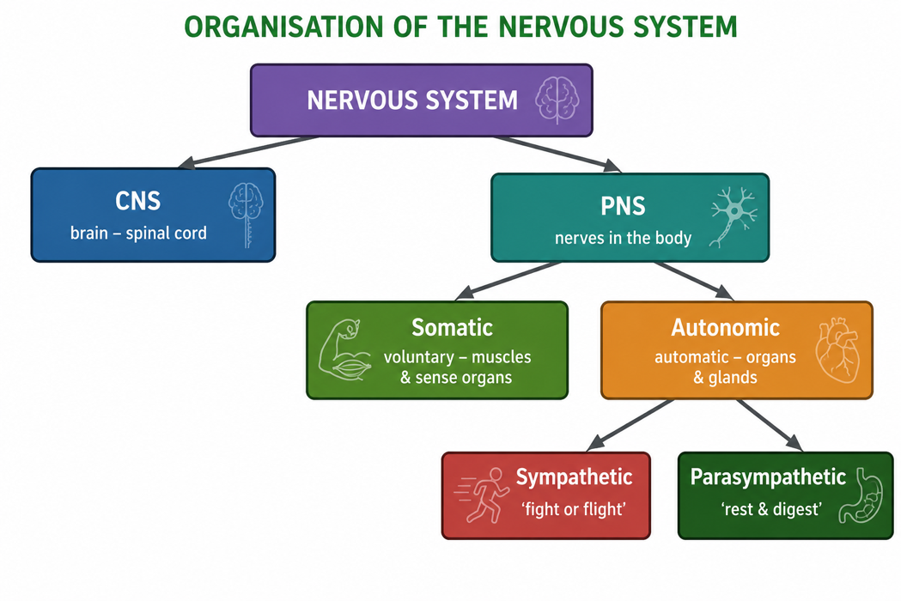
Figure 1: The organisation of the nervous system into central and peripheral divisions.
Terminologies and Concepts
Useful terms for this topic:
- Neuron: a nerve cell that carries electrical impulses.
- CNS: the central nervous system - the brain and spinal cord.
- PNS: the peripheral nervous system - the nerves outside the CNS.
- Stimulus: a change in the environment that a receptor can detect.
- Synapse: the junction between two neurons where a signal is passed on.
- Neurotransmitter: a chemical that carries the signal across a synapse.
- Effector: a muscle or gland that produces the response.
The Neuron - The Building Block
The nervous system is built from billions of neurons. A typical neuron has three main parts. Dendrites are branched fibres that receive signals from other neurons. The cell body contains the nucleus and keeps the cell alive. The axon is a long fibre that carries the impulse away to the axon terminals, which pass the signal on. Many axons are wrapped in a fatty myelin sheath that greatly speeds up the impulse. There are three functional types: sensory neurons (carry signals to the CNS), motor neurons (carry signals from the CNS), and interneurons (connect neurons within the CNS).

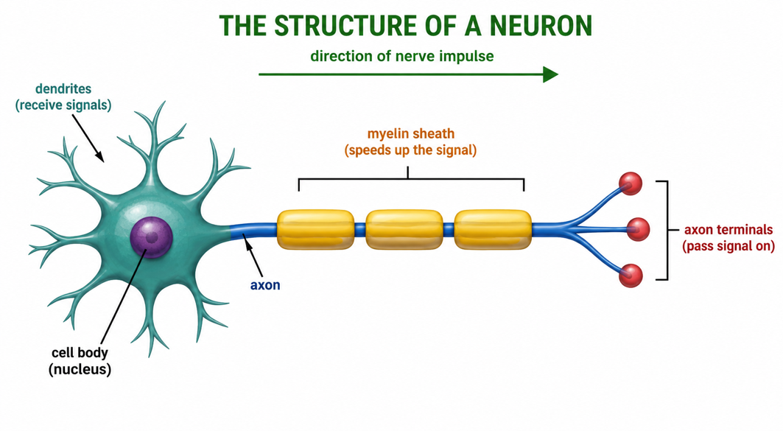
Figure 2: The structure of a neuron - dendrites receive, the axon carries the impulse, and terminals pass it on.
How Neurons Signal - Impulses and Synapses
A nerve impulse is an electrical signal that travels along the axon as a wave of changing charge (an action potential), driven by the movement of ions across the membrane. When the impulse reaches the end of the axon, it must cross a tiny gap to the next neuron - the synapse. Here the electrical signal triggers the release of neurotransmitter chemicals, which cross the gap and pass the signal to the next cell. In this way signals travel quickly along neurons and are relayed precisely from one neuron to the next, building the pathways that control the whole body.
The Three Jobs of the Nervous System
All nervous activity follows the same three-step pattern. First, sensory input: receptors detect a stimulus (light, sound, touch, temperature) and send signals to the CNS. Second, integration: the CNS processes the information and decides on a response. Third, motor output: signals travel to effectors - muscles or glands - which carry out the response. A reflex arc, such as pulling your hand off something hot, is the fastest example of this pattern.
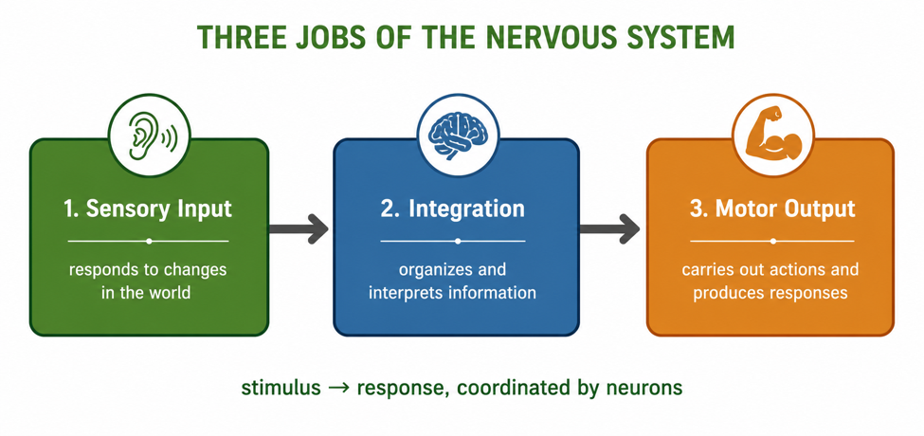
Figure 3: The three jobs of the nervous system - sensory input, integration, and motor output.
Somatic and Autonomic Control
The somatic system controls voluntary actions - the skeletal muscles you move on purpose - and carries information from the sense organs. The autonomic system runs the body automatically, without conscious thought, controlling the heart, gut, glands and other organs. Its two branches are opposites that keep the body balanced: the sympathetic branch prepares the body for action ('fight or flight' - heart rate up, pupils wide), while the parasympathetic branch calms it down ('rest and digest' - heart rate down, digestion active).
Why This Matters
- Foundation - this design underlies every later topic on the senses, brain and behaviour.
- Health - understanding neurons helps explain disorders like epilepsy and MS.
- Reflexes and safety - the sensory–motor pathway protects the body from harm.
- Technology - neuron signalling inspires robotics, sensors and brain–machine links.
PNG Context Example
Understanding the nervous system is important for health in Papua New Guinea. Conditions that affect the nerves and brain - such as cerebral malaria, meningitis, epilepsy, stroke and snakebite (some PNG snakes have venom that attacks the nervous system) - are serious health concerns. Knowing how neurons carry signals and how the CNS and PNS work helps students understand how these conditions cause paralysis, seizures or loss of sensation, and why fast treatment matters - building a foundation for careers in medicine, nursing and health science.
References & Related Documents
Source Documents
- STEM Biology Syllabus - Grade 12. Thema: Neurophysiology; Module: General Design of the Nervous System (advanced). Department of Education, PNG.
- Biology Standards-Based Syllabus, Grades 11 & 12 (PNG SBC 2020) - Strand 2: Life; investigate how the nervous system detects stimuli and coordinates responses to maintain homeostasis.
Further Reading & References
- OpenStax Biology - The Nervous System; Neurons and Glial Cells; Nerve Impulse Transmission. https://openstax.org/books/biology
- Khan Academy - The nervous system and neurons. https://www.khanacademy.org/science/biology/human-biology

